1. Starting with an empty binary heap, show the following.

1. The state of the heap after adding in the values: 20, 16, 17, 6, 10, 18, 11, 8, 3
2. The state of the heap after two Dequeue() operations
3. The final, array-based version of the heap

2. Perform a dequeue operation on the following **skew min-heap**. Draw the results.

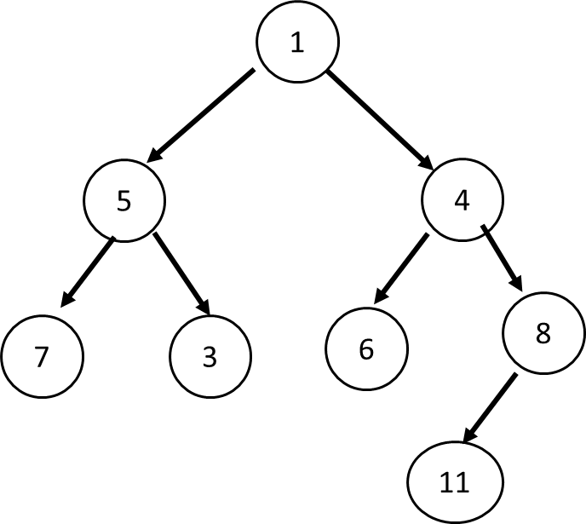

3. Starting with the supplied binomial heap, add the values   
10, 9, 7, 3, and 6. Draw the result.

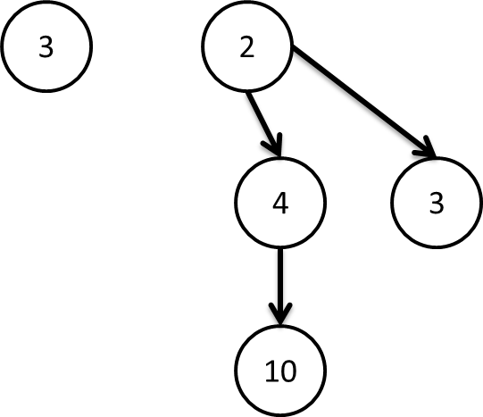

4. Perform 3 dequeue operations on the following binomial heap:

